Planning phase

Contents

- Hold project kick off meeting
- Develop work plan
  - Develop work breakdown structure (WBS)
  - Develop project staffing plan
  - Develop project schedule
  - Develop project budget
- Develop project control plan
  - Communications plan
  - Quality management plan
  - Issue Management Plan
  - Change Management Plan
  - Risk Management Plan
  - Procurement Plan
  - Support Transition Plan
- Finalize Project Plan and gain approvals

Project Kickoff Meeting: Agenda

- Introductions (optional, if members are acquainted)

- Charter Review
  - Discuss the approved Project Charter
  - Clarify the charter through questions/answers

- Discuss Next Steps for Stakeholders
  - Read minutes and contribute additions/corrections
  - Provide input for the Work Plan and Control Plan
  - Review Project Plan at a future meeting

Work Breakdown Structure outline:

Task Name
start
Mobility
finding office
landscape
utility connections "water and electricity"
delivering computers
Recruitment
managers
developers
testers
designers
Buses network planning
ordering buses and delivery
Drivers Recruitment
buses routes planning
Buses launching
drivers training on routes
starting buses trips
ordering taplets and delivery
Designing
designing website
designing application
Developing
website
frontend
backend
IOS application
fontend
backend
android application
forntend
backend
Testing
website
android application
IOS application
drivers training on how to use the system
Launching
website
IOS application
android application
close

Work Breakdown Structure
Work Breakdown Structure Diagram
(task numbering optional)



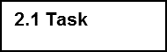
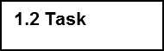
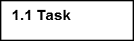
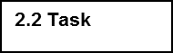

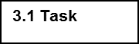
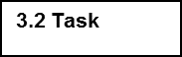

 | 1.1.1 Sub-task |  | 2.1.1 Sub-task |  | 2.1.1 Sub-task |  | 2.1.1 Sub-task |  | 2.1.1 Sub-task |  | 2.1.1 Sub-task
 | 1.1.2 Sub-task |  | 2.1.2 Sub-task |  | 2.1.2 Sub-task |  | 2.1.2 Sub-task |  | 2.1.2 Sub-task |  | 2.1.2 Sub-task
 | 1.1.3 Sub-task |  | 2.1.3 Sub-task |  | 2.1.3 Sub-task |  | 2.1.3 Sub-task
 | 1.1.4 Sub-task |  |  |  | 2.1.4 Sub-task

Staffing Plan

Role Requirements

Role | Project Responsibility | Skills Required | # of persons | Estimated start date | Duration Required  FYyy-yy
Project manager | management | Project management | 1 | From the start of the project | The end of the project
Drivers manager | Solve drivers problems | Good communication skills | 1 | 15/11/2017 | forever
Designer | design website and mobile app. | Web design | 2 | 2/7/2017 | One month
tester | Testing the two applications | Problem solving and troubleshooting | 2 | 1/1/2018 | One month
Developers | Developing the website and the mobile application. | Can work with web, IOS and android. | 3 | 1/8/2017 | 8 months
Sales | Buying all required components, making deals and receiving them. | Can get good offers and high quality.  Honest. | 1 | From the start of the project | Till the end of the project
Developing manager | He is the supervisor of the software team. | Can manage people.  Knows about software developing. | 1 | From the start of the project | Till the end of the project

Staff Assigned to Roles

Role | Name | Requested  FTE  FYyy-yy | Acquired FTE  FYyy-yy | Rate | Rate Unit
Project manager | Yomna Alaa | 30000 | 20000 | 1000 | day
Drivers manager |  | 10000 | 7000 | 350 | day
Designer |  | 15000 | 10000 | 500 | day
Tester |  | 10000 | 7000 | 350 | day
Developers |  | 15000 | 10000 | 500 | day
Sales |  | 15000 | 10000 | 500 | day
Developing manager |  | 20000 | 17000 | 850 | day

Staff Resource Loading Chart

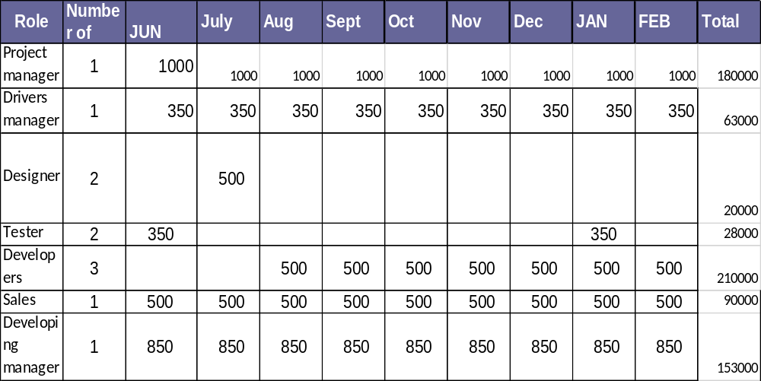

Training Needs

Role/Staff Resource | Training Need | Timeframe Needed
Drivers | Knowing the routes and how to treat with the buses | 7 days
Drivers | How to use the system efficiently | 10 days

PROJECT ORGANIZATION CHART

Drivers manager

Project manager

Developing manager

Sales man

Web Developer

Mobile developer

tester

designer

Project Schedule:

WBS | Task Name | Duration | Start | Finish | Resource Names
1 | start | 1 day | Thu 6/1/17 | Thu 6/1/17
2 | Mobility | 13 days | Thu 6/1/17 | Mon 6/19/17
2.1 | finding office | 3 days | Thu 6/1/17 | Sat 6/3/17
2.2 | landscape | 4 days | Mon 6/5/17 | Thu 6/8/17
2.3 | utility connections "water and electricity" | 6 days | Fri 6/9/17 | Fri 6/16/17
2.4 | delivering computers | 4 days | Wed 6/14/17 | Mon 6/19/17 | Sales
3 | Recruitment | 10 days | Sun 6/18/17 | Thu 6/29/17
3.1 | managers | 5 days | Sun 6/18/17 | Thu 6/22/17
3.2 | developers | 5 days | Sun 6/25/17 | Thu 6/29/17 | Project manager ,Developing manager
3.3 | testers | 5 days | Sun 6/25/17 | Thu 6/29/17 | Project manager ,Developing manager
3.4 | designers | 5 days | Sun 6/25/17 | Thu 6/29/17 | Project manager ,Developing manager
4 | Buses network planning | 120 days | Thu 6/15/17 | Wed 11/29/17
4.1 | ordering buses and delivery | 6 mons | Thu 6/15/17 | Wed 11/29/17 | Sales
4.2 | Drivers Recruitment | 7 days | Wed 11/15/17 | Thu 11/23/17 | Drivers manager
4.3 | buses routes planning | 1 mon | Tue 8/1/17 | Mon 8/28/17 | Project manager
5 | Buses launching | 8 days | Sun 12/3/17 | Tue 12/12/17
5.1 | drivers training on routes | 7 days | Sun 12/3/17 | Sun 12/10/17 | Buses[1],Drivers manager
5.2 | starting buses trips | 1 day | Tue 12/12/17 | Tue 12/12/17 | Buses[1],Drivers manager
6 | ordering taplets and delivery | 1 mon | Sun 10/22/17 | Thu 11/16/17 | Sales
7 | Designing | 20 days | Sun 7/2/17 | Thu 7/27/17
7.1 | designing website | 1 mon | Sun 7/2/17 | Thu 7/27/17 | Designer
7.2 | designing application | 1 mon | Sun 7/2/17 | Thu 7/27/17 | Designer
8 | Developing | 108 days | Tue 8/1/17 | Thu 12/28/17
8.1 | website | 43 days | Tue 8/1/17 | Thu 9/28/17 | computers[1],Developers
8.1.1 | frontend | 1 mon | Tue 8/1/17 | Mon 8/28/17 | computers[1],Developers
8.1.2 | backend | 1 mon | Tue 8/29/17 | Mon 9/25/17 | computers[1],Developers
8.2 | IOS application | 43 days | Sun 10/1/17 | Tue 11/28/17 | computers[1],Developers
8.2.1 | fontend | 1 mon | Tue 9/26/17 | Mon 10/23/17 | computers[1],Developers
8.2.2 | backend | 1 mon | Wed 11/1/17 | Tue 11/28/17 | computers[1],Developers
8.3 | android application | 42 days | Wed 11/1/17 | Thu 12/28/17 | computers[1],Developers
8.3.1 | forntend | 1 mon | Wed 11/1/17 | Tue 11/28/17 | computers[1],Developers
8.3.2 | backend | 1 mon | Sun 12/3/17 | Thu 12/28/17 | computers[1],Developers
9 | Testing | 24 days | Mon 1/1/18 | Thu 2/1/18 | computers[1]
9.1 | website | 7 days | Mon 1/1/18 | Tue 1/9/18 | computers[1],Tester
9.2 | android application | 7 days | Wed 1/10/18 | Thu 1/18/18 | computers[1],Tester
9.3 | IOS application | 7 days | Sun 1/21/18 | Sun 1/28/18 | computers[1],Tester
9.4 | drivers training on how to use the system | 10 days | Sun 1/21/18 | Thu 2/1/18 | tablets[1],Buses[1],Tester
10 | Launching | 13 days | Sun 2/4/18 | Tue 2/20/18
10.1 | website | 3 days | Sun 2/4/18 | Tue 2/6/18 | tablets[1],servers[1],Developers ,Tester
10.2 | IOS application | 4 days | Wed 2/7/18 | Sun 2/11/18 | tablets[1],servers[1],Developers ,Tester
10.3 | android application | 3 days | Mon 2/12/18 | Wed 2/14/18 | tablets[1],servers[1],Developers ,Tester
11 | close | 1 day | Thu 3/1/18 | Thu 3/1/18

Network Diagram:
That it is impossible to screenshot the whole diagram so it is devided into many pictures
First this is the whole diagram but without any details:

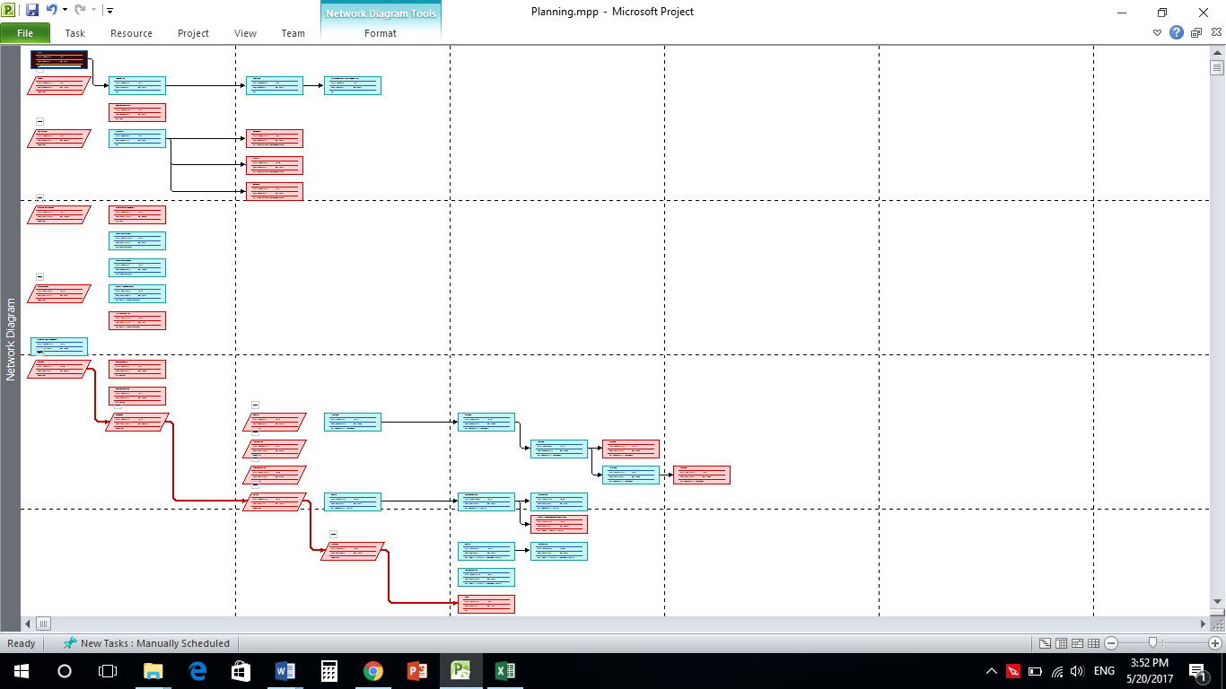

And then these are the details of the diagram:

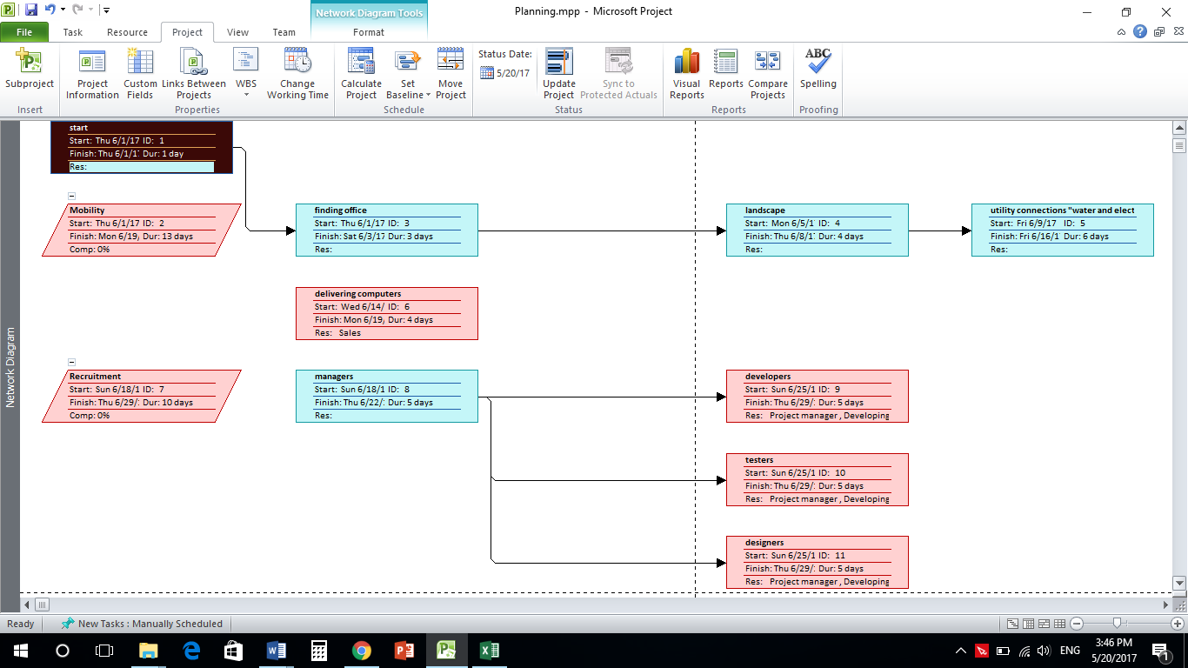
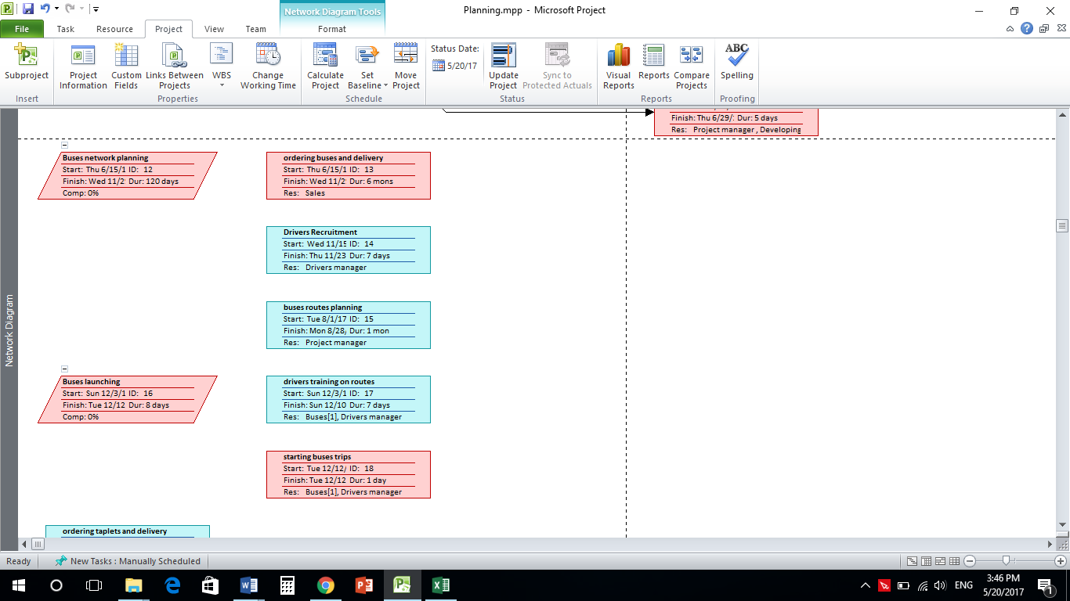

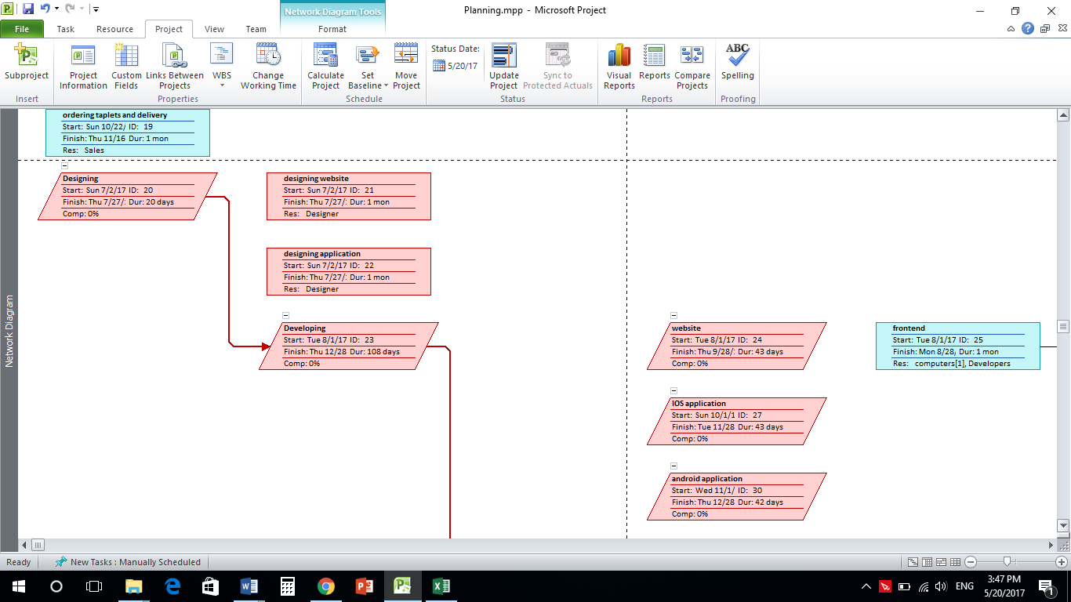

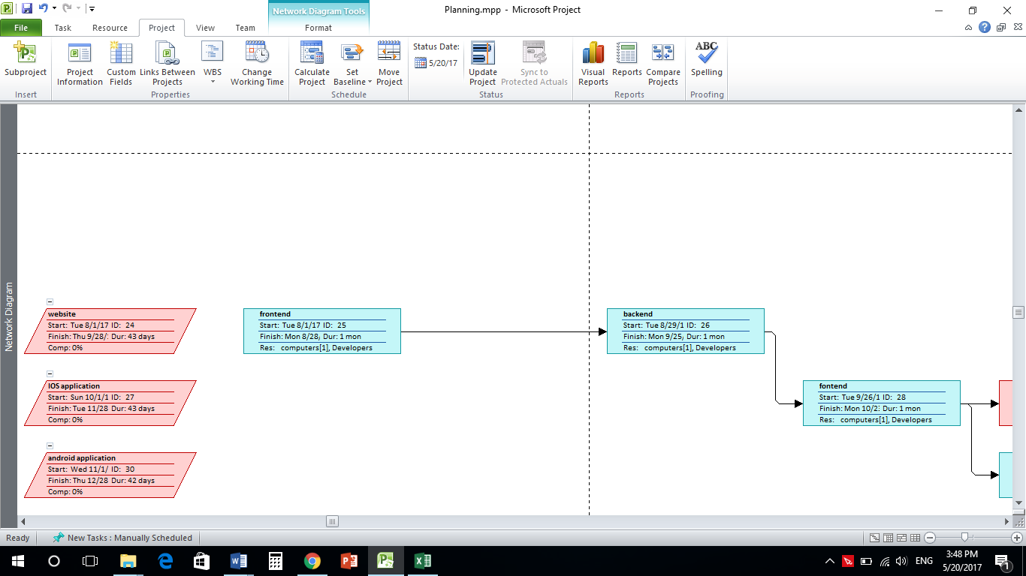

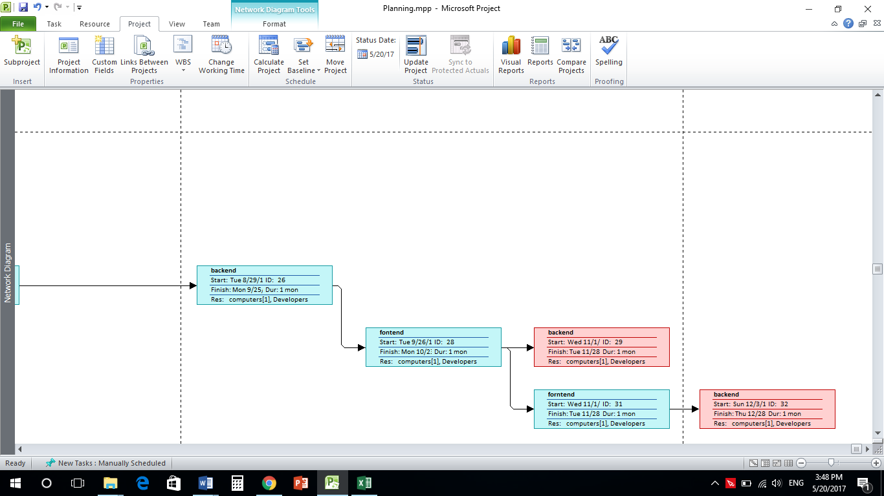

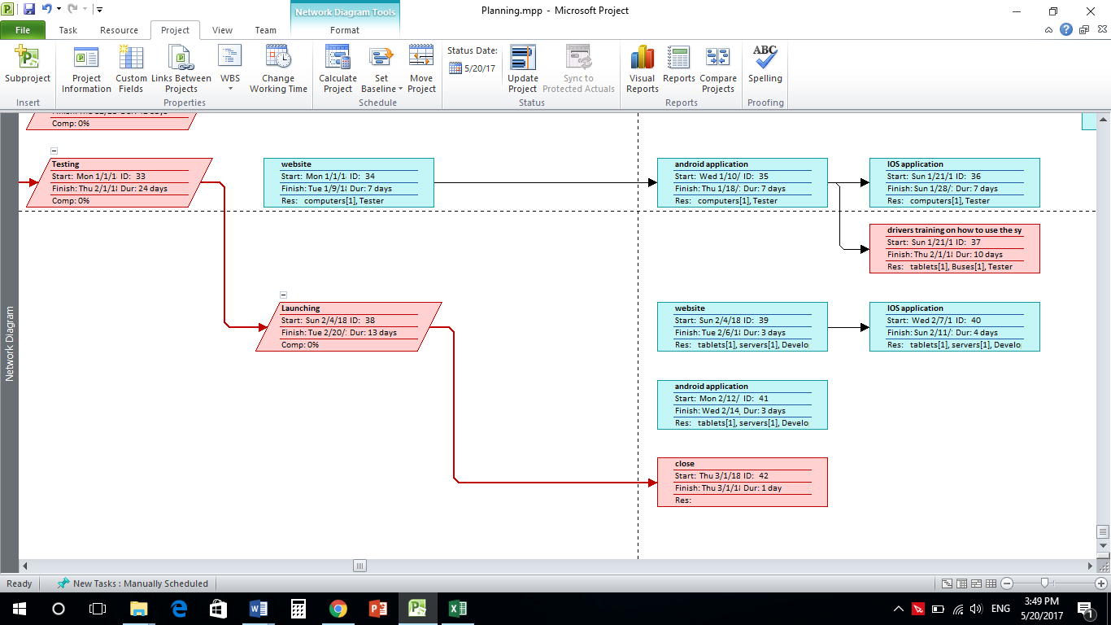

Gantt Chart:

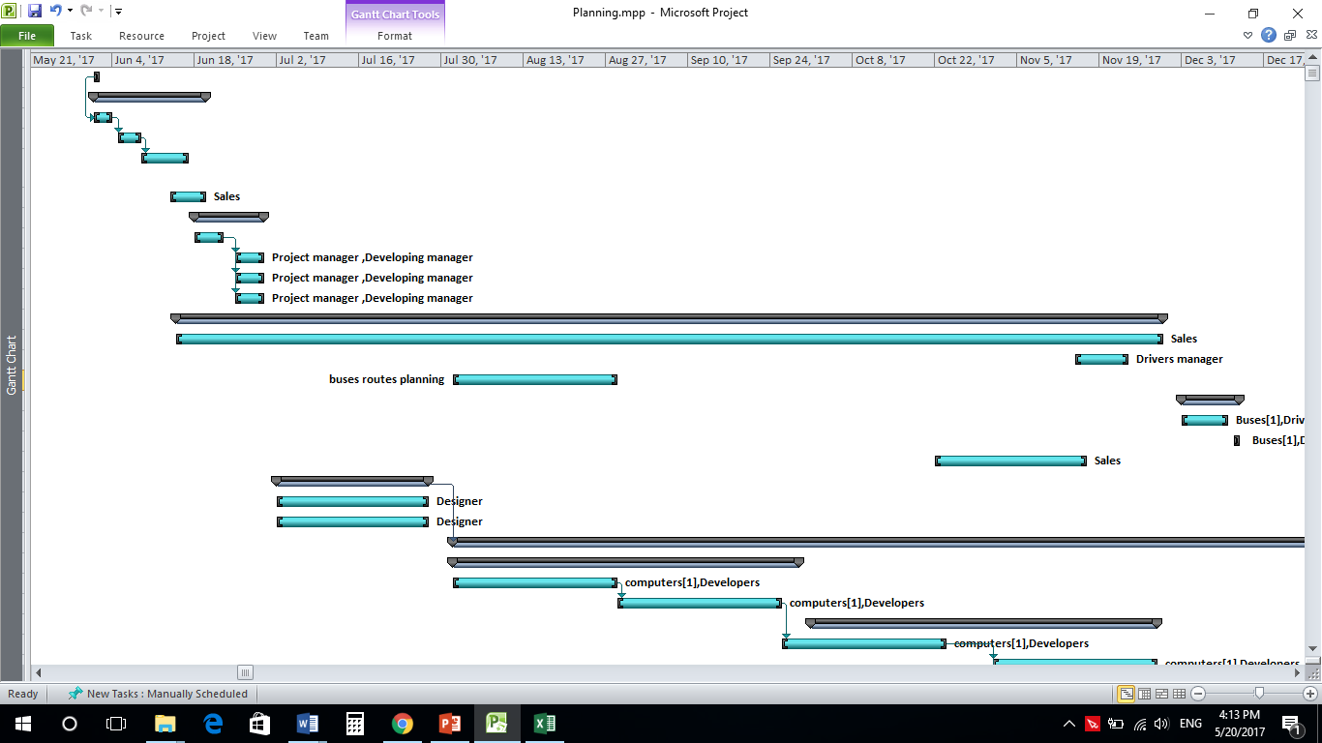

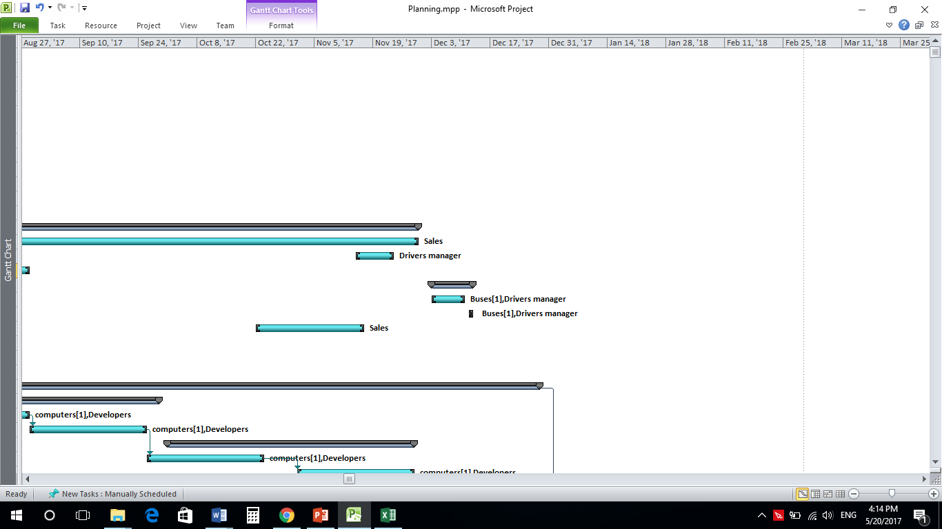

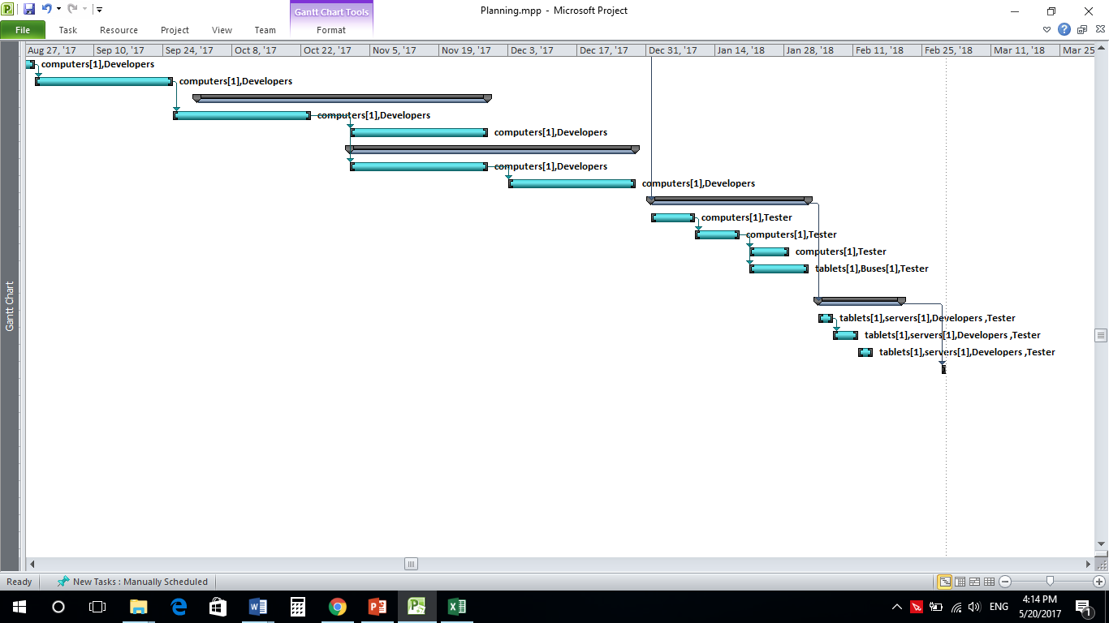

Project Budget

PROJECT BUDGET INFORMATION

Budget during the life of the Project

Line Item | FY05-06
 | Labor | Material | Other | Cost
start | 2,700.00 ج.م.‏ |  |  | 2,700.00 ج.م.‏
Mobility | 35,100.00 ج.م.‏ |  |  | 35,100.00 ج.م.‏
finding office |  |  |  | 0.00 ج.م.‏
landscape |  |  |  | 0.00 ج.م.‏
utility connections "water and electricity" |  |  |  | 0.00 ج.م.‏
delivering computers |  |  |  | 0.00 ج.م.‏
Recruitment | 27,000.00 ج.م.‏ |  |  | 27,000.00 ج.م.‏
managers |  |  |  | 0.00 ج.م.‏
developers |  |  |  | 0.00 ج.م.‏
testers |  |  |  | 0.00 ج.م.‏
designers |  |  |  | 0.00 ج.م.‏
Buses network planning | 324,000.00 ج.م.‏ |  |  | 324,000.00 ج.م.‏
ordering buses and delivery |  |  |  | 0.00 ج.م.‏
Drivers Recruitment |  |  |  | 0.00 ج.م.‏
buses routes planning |  |  |  | 0.00 ج.م.‏
Buses launching | 21,600.00 ج.م.‏ | 30,000,000 ج.م.‏ |  | 30,021,600.00 ج.م.‏
drivers training on routes |  |  |  | 0.00 ج.م.‏
starting buses trips |  |  |  | 0.00 ج.م.‏
ordering taplets and delivery |  |  |  | 0.00 ج.م.‏
Designing | 64,000.00 ج.م.‏ |  |  | 64,000.00 ج.م.‏
designing website |  |  |  | 0.00 ج.م.‏
designing application |  |  |  | 0.00 ج.م.‏
Developing |  |  |  | 200,000.00 ج.م.‏
website | 50,000.00 ج.م.‏ |  |  | 50,000.00 ج.م.‏
frontend |  |  |  | 25,000.00 ج.م.‏
backend |  |  |  | 25,000.00 ج.م.‏
IOS application | 50,000.00 ج.م.‏ |  |  | 50,000.00 ج.م.‏
fontend |  |  |  | 25,000.00 ج.م.‏
backend |  |  |  | 25,000.00 ج.م.‏
android application | 50,000.00 ج.م.‏ |  |  | 50,000.00 ج.م.‏
forntend |  |  |  | 25,000.00 ج.م.‏
backend |  |  |  | 25,000.00 ج.م.‏
Testing | 123,200.00 ج.م.‏ |  |  | 123,200.00 ج.م.‏
website |  |  |  | 0.00 ج.م.‏
android application |  |  |  | 0.00 ج.م.‏
IOS application |  |  |  | 0.00 ج.م.‏
drivers training on how to use the system |  |  |  | 50,000.00 ج.م.‏
Launching | 35,100.00 ج.م.‏ | 1,000,000.00 ج.م.‏ |  | 1,035,100.00 ج.م.‏
website |  |  |  | 0.00 ج.م.‏
IOS application |  |  |  | 0.00 ج.م.‏
android application |  |  |  | 0.00 ج.م.‏
close | 2,700.00 ج.م.‏ |  |  | 2,700.00 ج.م.‏
Total |  |  |  | 32,035,400.00

On-going Support Budget after Project Completion

Line Item | FYyy-yy | # of times per month | Total Budget per month
Software maintenance | 20000 | 2 | 40000
Hardware maintenance | 50000 | 1 | 50000
3G network | 3000 | 1 | 3000
Parking rental | 25000 | 30 | 750000
Total Budget | 98000 |  | 843000

Communication Plan

Document Change Control

The following is the document control for the revisions to this document.
Version Number | Date of Issue | Author(s) | Brief Description of Change

Definition

The following are definitions of terms, abbreviations and acronyms used in this document.

Term | Definition

Table of Contents

1. Introduction 1

2. Communication Objectives 1

3. Communication Purpose and Target Audiences 1

4. Communication Message and Delivery 2

5. Communication Message Contents 3

Appendix 4
Target Audience Participants 4

- Introduction

The purpose of the communication plan is to ensure the Project Management Improvement Project provides relevant, accurate, and consistent project information to project stakeholders and other appropriate audiences. By effectively communicating the project can accomplish its work with the support and cooperation of each stakeholder group.

The communication plan provides a framework to manage and coordinate the wide variety of communications that take place during the project. The communication plan covers who will receive the communications, how the communications will be delivered, what information will be communicated, who communicates, and the frequency of the communications.

2. Communication Objectives

Effective and open communications is critical to the success of the project.

The key communication objectives for the project are:

[Enter the key communications objectives for the project.]

3. Communication Purpose and Target Audiences

This section identifies the audiences targeted in this Communication Plan, and the purpose of communicating with each audience. A complete list of the participants in each audience can be found in the Appendix.

Audience | Communication Purpose

4. Communication Message and Delivery

The following outlines the targeted audiences, the key communication messages to be delivered, and the method for delivering the information, the communicator, and the frequency of the delivery.

Audience | Message | Delivery Method | Delivery Frequency | Communicator

5. Communication Message Contents

The section outlines the contents of the key communications.

[Enter the key communications for your project and the major items of information that will be included in each communication.
For example:
A Project Briefing might include:
- Goals of the project
- Project Status
- Project Problems and Issues
- Project Checklist]

Appendix

Target Audience Participants

[Enter the general audience type such as Steering Committee or Project Team, the names of the participants and the participant’s organization.]

Audience | Participants | Organization

Template: Issue Management Plan EZ
Change the template as appropriate for your project. Fill out sections with enough details for your project.

Project Name | Project name
Project Manager | Project manager name | Organization | Organization name
Sponsor | Sponsor name | Organization | Organization name
Customer | Customer name | Organization | Organization name
Document Version and Date | Version number and date of this document.

Term, Abbreviation or Acronym | Definition

Issue Management Plan Components
General goals and approach | A goal of this project is to identify issues as soon as they arise and to resolve them expeditiously. All team members are enjoined to be vigilant, particularly in their areas of expertise, but also to raise issues outside of their areas of specific responsibility when they become aware of them.  If additional specific goals for issue management were set in the project charter, state briefly what actions will be taken to achieve these goals.
Issue management categories and rules | Priority Categories - [provide specific categories and the rules for their application]  Escalation Rules - [provide specific rules for escalating issues]  Monitoring Frequency - [Note the frequency with which issues are to be reviewed with the project team.]
Roles and responsibilities | [Specify each issue management role and responsibility. For decision makers, note any special expertise that may be required given the types of issues you can anticipate. This sets the stage for ensuring access to that expertise.]
  Role | Responsibility | Expertise
Issue management process | [Briefly state the process to be followed. Include, for example, the following subject areas.]
  Process Name | Process Activity
  Identification
  Prioritization
  Tracking
  Escalation
  Assignment of issue for resolution
  Monitor issue status
  Communication
  Close resolved issues
Tools | [Refer to the issue log and any other related tools used by your project.]

Template: Change Management Plan EZ
Change the template as appropriate for your project. Fill out sections with enough details for your project.

Project Name | Project name
Project Manager | Project manager name | Organization | Organization name
Sponsor | Sponsor name | Organization | Organization name
Customer | Customer name | Organization | Organization name
Document Version and Date | Version number and date of this document.

Term, Abbreviation or Acronym | Definition

Risk Management Plan Components
Project Constraints | [Identify the driving constraints for the project. These are the assumptions against which change is managed. Examples:  - fixed budget set at $_______  - hard deadline  - minimum quality threshold.]
Change management guidelines and purview | The following items will be subject to change management.  [Specify list of primary deliverables and the documents that describe them, and secondary deliverables that will fall under change management.]  The project team has latitude [is strictly bound] to interpret requirements in the following areas:  [Specify list of areas in the product specification or requirements where the project team is either strictly bound by the documents or has the prerogative to interpret the requirements more loosely.]
Estimate of change volume | The budgetary impact of change in this project is expected to fall within the range of [lower] to [higher] dollars. We assume the number of change requests will be roughly ____. We estimate change evaluation and management to require _____ hours.
Roles and responsibilities | [Specify each change management role and responsibility. For evaluators, note any special expertise that may be required given the sorts of changes you can anticipate. This sets the stage for ensuring access to that expertise.]
  Role | Responsibility | Expertise
Change management process | [Briefly state the process to be followed. Include, for example, the following subject areas.]
  Process Name | Process Activity
  Submittal and Logging
  Evaluation
  Decision
  Integration
  Communication
Tools | [Refer to the change request form, the change log, and any other tools used by your project.]

Template: Risk Management Plan EZ
Change the template as appropriate for your project. Fill out sections with enough details for your project.

Project Name | Project name
Project Manager | Project manager name | Organization | Organization name
Sponsor | Sponsor name | Organization | Organization name
Customer | Customer name | Organization | Organization name
Document Version and Date | Version number and date of this document.

Term, Abbreviation or Acronym | Definition

Risk Management Plan Components
General assessment and approach | This general level of risk to this project is [make a brief statement indicating high, medium, or low level of risk]  The project will approach risk management as follows:  - [make a brief statement indicating whether an aggressive, moderate, or low level of risk management is intended. (E.g., an aggressive approach might include weekly monitoring for occurrence of risk factors and immediate response to any realized risks.)  - indicate whether a qualitative, quantitative, or combined risk analysis approach will be used
Risk management definitions | Risk Likelihood Categories - [provide specific qualitative or quantitative measures]  Risk Impact Categories - [provide specific qualitative or quantitative measures]  Response Strategies – [adopt or modify the following: avoidance, mitigation, transference, acceptance.]
Roles and responsibilities | [Specify each risk management role and responsibility. For decision makers, note any special expertise that may be required given the types of risks you can anticipate. This sets the stage for ensuring access to that expertise.]
  Role | Responsibility | Expertise
Risk management process | [Briefly state the process to be followed. Include, for example, the following subject areas.]
  Process Name | Process Activity
  Monitor for occurrence of risk factors
  Evaluation
  Consultation
  Response
  Logging
  Communication
Tools | [Refer to the risk register, risk control log, and any other tools used by your project.]

ID# | Risk Name | Description of risk | Risk factors to monitor | Likeli-hood | Impact level | Tolerance of risk | Threshold of risk | Response | Responsible Person | Update date
Assign ID number | Give a brief name for the risk | Describe the risk and discuss potential impacts | Describe factors to monitor that may trigger realization of this risk. | From project likelihood categories | From project impact categories | State stakeholder tolerance of this risk (e.g., high, medium, low) | State any stakeholder quantitative threshold established by stakeholder | Indicate the response strategy and specific response. (If applicable, also note project action to be taken in WBS.) (e.g., Mitigate: reduce probability of contributing factor's occurrence.) | Enter person(s) responsible for implementing the response. | Enter last update date

Template: Project Plan EZ
Change the template as appropriate for your project. Fill out sections with enough details for your project.

Project Name | Project name
Project Manager | Project manager name | Organization | Organization name
Sponsor | Sponsor name | Organization | Organization name
Customer | Customer name | Organization | Organization name
Document Version and Date | Version number and date of this document.

Term, Abbreviation or Acronym | Definition

Project Plan Overview and Critical Assumptions
Overview and Goals | OPTIONAL  Briefly give a project overview, including any relevant background information, such as project goal and high-level description of the objective(s).
Critical Assumptions | OPTIONAL  List the critical assumptions for the project, if stated in the Project Charter EZ Changes to key assumptions may impact schedule, costs, scope, and or quality. Examples include deadlines, financial or budgetary items, resource availability, environment, technology, security, etc.

Project Work Plans
Work Breakdown Structure | ENCOURAGED  The work breakdown structure (WBS) is a hierarchical definition of tasks and activities that need to be performed to complete your project. Put into an appendix if necessary.  Enter the WBS with sufficient detail for your purposes. Include major activities to be accomplished and tasks associated with these activities.
Staffing Plan | ENCOURAGED  The staffing plan outlines the skills and staff resources needed to deliver the project deliverables.  Enter the Staffing Plan for your project. Match skill sets with individuals and establish time commitments.
  Role | Name | Start Date | End Date | Required FTE FYyy-yy
Project Schedule | REQUIRED  Enter the Project Schedule. Include time estimates, start and finish dates, names of assigned resources, and current status for all tasks and activities. Put into an appendix if necessary.
Project Budget | REQUIRED  The project budget describes cost and budget needed to complete the project tasks.  Enter costs for labor, material and other expense items. If the on-going maintenance and support costs are required by your project include this information.
Project Budget | Cost Type | FYyy-yy | FYzz-zz | Total
Project Budget | Total Budget

Project Control Plans
Communication Plan | REQUIRED - Provide a brief statement or refer to an appendix.  Define the information needs of the project stakeholders and the team by documenting what, when, where, and how project information will be disseminated.
Quality Management Plan | NOT APPLICABLE - Provide a brief statement or refer to an appendix.  Define the quality control and quality assurance activities and associated responsible resources. Examples include methodologies, standards, documentation, change, issue, and problem management, and review and acceptance procedures (testing, sign-off, etc.)
Issue Management Plan | NOT APPLICABLE - Provide a brief statement or refer to an appendix.  Define how issues are identified, evaluated, assigned, and tracked for resolution. Refer to detailed Issue management plan template for further guidelines.
Change Management Plan | NOT APPLICABLE - Provide a brief statement or refer to an appendix.  Define how changes are identified, evaluated, assigned, and tracked for resolution. Changes impact scope, schedule, budget, and quality. Refer to detailed Change management plan template for further guidelines.
Risk Management Plan | ENCOURAGED - Provide a brief statement or refer to an appendix.  Define how risks are identified, evaluated, monitored, and remedied.  Summarize major risks, mitigation strategies and associated costs, and overall assessment of level of risk to project. Refer to detailed Risk management plan template for further guidelines.
Procurement Plan | OPTIONAL - Provide a brief statement or refer to an appendix.  Summarize purchasing products or services for project. Include projected dates for critical procurement tasks.
Support Transition Plan | REQUIRED - Provide a brief statement or refer to an appendix.  Summarize tasks to prepare for transition to support organization. Include projected dates for completing documentation and review of Change Management request, Configuration Management, Help Desk, and Service Management.

Project Plan Approval Signatures

Project Manager

_______________________________________ __________________
(Signature) (Date)
Name
Position
Organization

Project Sponsor

_______________________________________ __________________
(Signature) (Date)
Name
Position
Organization

Project Customer

_______________________________________ __________________
(Signature) (Date)

Name
Position
Organization

Appendices

Template: Project Plan Approval Signatures

Project Name:

Project Manager
_______________________________________ __________________
(Signature) (Date)
Name
Position
Organization

Project Sponsor
_______________________________________ __________________
(Signature) (Date)
Name
Position
Organization
Organization

Project Customer
_______________________________________ __________________
(Signature) (Date)
Name
Position
Organization

Project Customer
_______________________________________ __________________
(Signature) (Date)
Name
Position
Organization
Enter the project name.

Replace Name with the name of the approver fulfilling the role.
Replace the Position with the approver’s position.
Replace the Organization with the approver’s organization.

The approving person adds their approval signature and the date the approval is signed.

